Dictionary

\*hyuha={7:7,9:8,90:34}

print(type(hyuha))

Key should not have repeated value, should be unique.

The element can be accessed only using the key. If values are used you get a keyerror

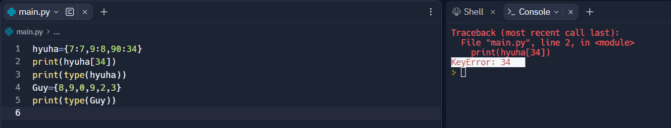

Dict are mutable:

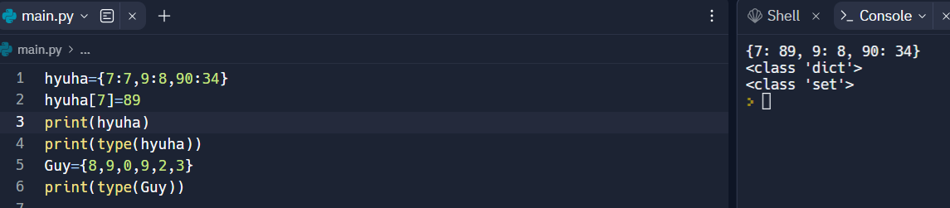

Adding new element;

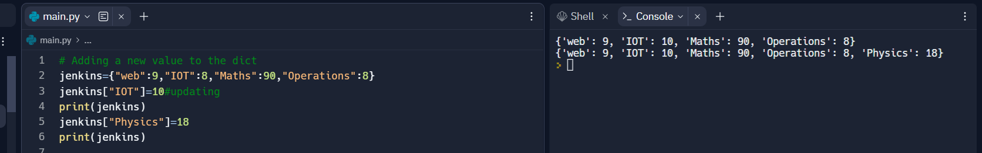

Operations:

There is only one operation can be perform—membership operator:

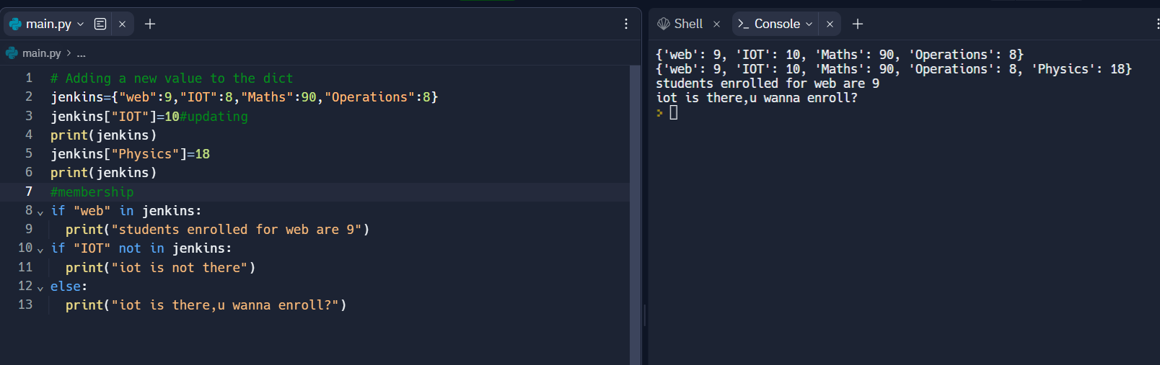

Traversing:

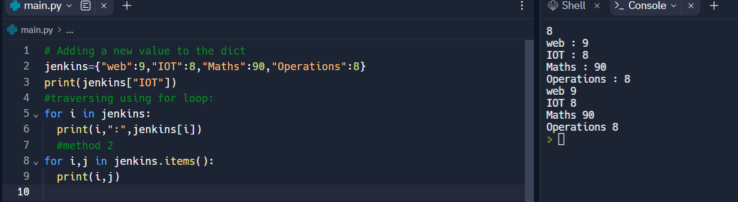

INBUILD functions:

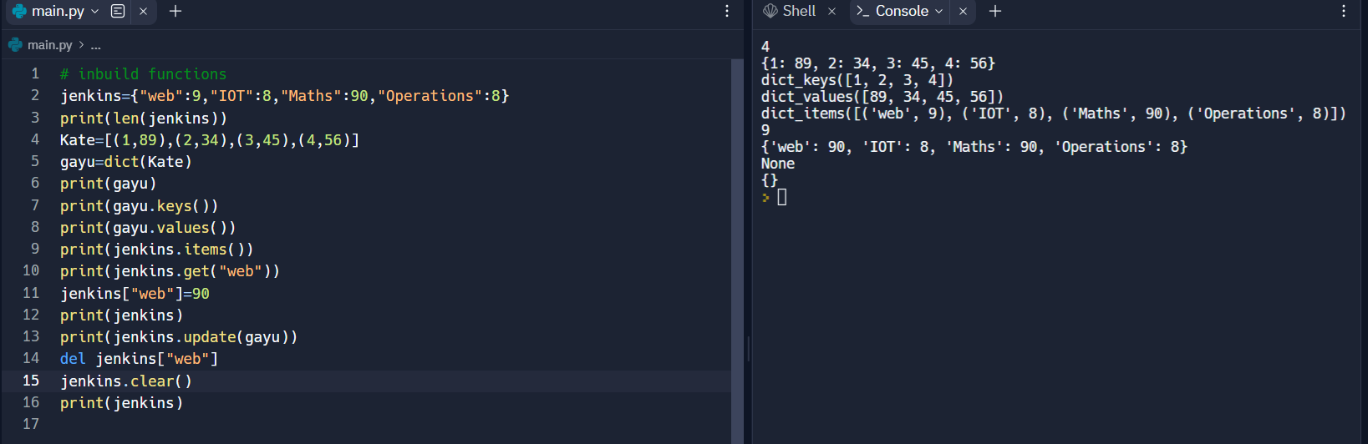

Sets:

Sets are immutable, can have all datatypes.

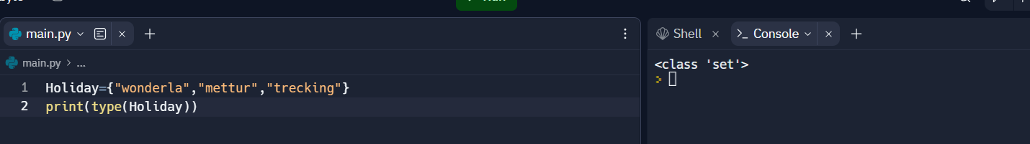

Accessing , updating and adding:

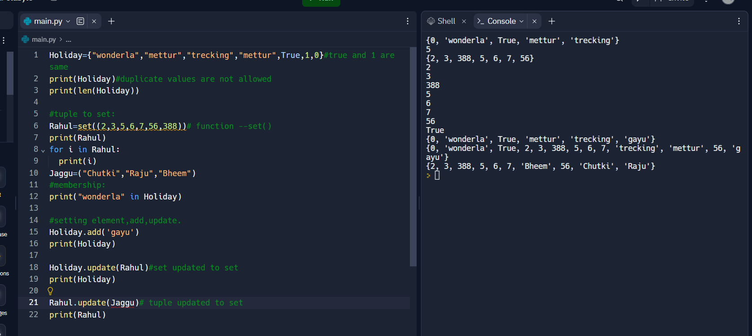

Union is similar update:

